Graf exceeds sales of
€100 million for the first time

Another record year: Teningen-based family-run business doubles turnover and workforce in ten years

In the 2017 financial year, the Graf Group from Teningen, southern Germany exceeded net sales of €100 million for the first time. The news was announced by the family-run business at a press conference held at the company’s headquarters in Teningen. Over the last ten years, sales and the number of employees has doubled thanks to strong internationalisation and consistent expansion of the sustainable water management range. “The positive trend shows that we have made the right strategic developments and are also very well positioned to build on our position as a market leader in our sector for the future,” says Otto P. Graf, Managing Director of the Graf Group.

Over the last financial year, in excess of 500 Graf employees have generated sales of €105 million. This is a 10 percent increase on the previous year. “The figures reflect the hard work put in by our highly motivated staff. No matter whether they work in production, sales or logistics, our staff are firmly committed to Graf and put all their energy and focus into achieving our goals. It is very impressive,” enthuses Otto P. Graf.

Sales have grown in all product areas and regions, demonstrating that the company’s growth has a broad foundation. Otto P. Graf is the second generation of the family to manage the company founded in 1962. There has been a strong focus on internationalisation over the last decade. The share of company products exported has risen from 49 to 56 percent. The Graf Group sells to more than 70 countries around the globe with offices in France, UK, Spain, Poland, Australia and China. The UK company has recently purchased a significantly bigger premises and plans are currently underway to expand production facilities in both Australia and Poland..

Firmly committed to its roots despite international growth

Despite further internationalisation, two thirds of staff are employed in Germany. Over the last ten years alone, around 150 more staff have been hired at the company headquarters in Teningen. Graf is particularly keen to offer its specialist staff qualified training with 15 young apprentices currently being trained in seven different departments within the organisation.

“Our success is driven by the success of our staff. Southern Bavaria is an attractive region with a good quality of life. As an attractive employer, we want to remain here and continue to drive the expansion of our company with a focus on our base in Teningen,” reinforces Otto P. Graf.

This success is most visible in the form of Graf’s new raw materials centre of expertise in Herbolzheim in which the family-run business is investing €35 million. These investments will be supplemented with funds from the German Federal Ministry for the Environment. The centre of expertise and its initial staff of forty will assume work in the summer of 2018. “We are still looking to take on staff and have only filled half the positions available so far,” reports Otto P. Graf.

Sustainability is in the company’s DNA

The recycling of plastic in house reduces unwanted carbon dioxide emissions twice over. Firstly, recycling used plastic produces only half the emissions of that generated from the manufacture of new raw materials and secondly, recycling avoids the incineration of plastic waste and the harmful emissions this produces as well as cutting exports.
Sustainability is firmly anchored in the DNA of the Graf group of companies: “We produce environmental products in a sustainably run production facility with sustainably processed raw materials,” explains Otto P. Graf. With a rapid urbanisation and huge population growth we can expect to see growing demand for our rainwater harvesting tanks, wastewater treatment plants and stormwater attenuation systems. “Water is our most important resource. We provide solutions for the global challenges associated with this precious resource, which therefore puts us in a very good position,” says the Managing Director of Graf as he looks to the future with optimism.

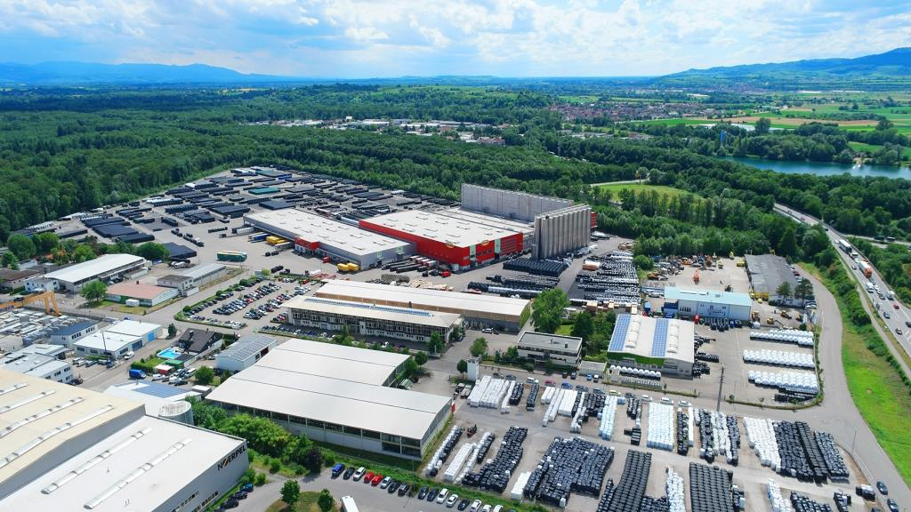
GRAF_PR_Luftbild_Teningen_05_10x15_rgb_300dpi
At its Teningen site, Graf produces products of the highest quality in one of the most modern production facilities for plastic products in the world.

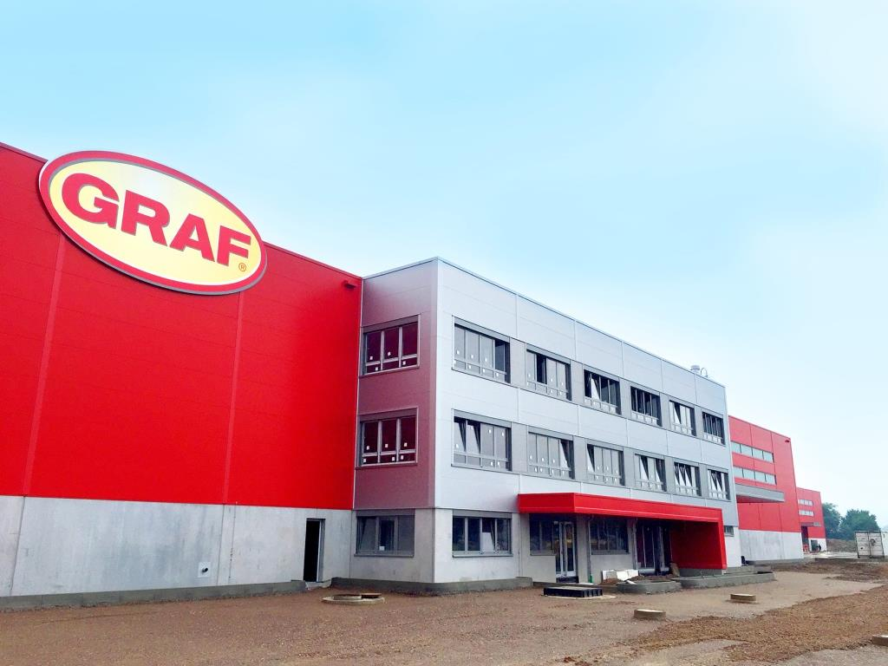
GRAF_PR_Kompetenzzentrum_Rohstoffe_Herbolzheim_10x15_rgb_300dpi.jpg
On 6.5 hectares of land in Herbolzheim, the company is constructing a new building which will cover about 24 000 m² and have twelve raw material silos, each 30 m high.

